

DOCUMENT TITLE | REVISION
SRP8-045-46 Front & Rear Brakes Preliminary Design | 0

Created By | Date
Madhav Katarya | 20/10/24

Department | Subsystem
Vehicle Dynamics | Brakes

REVISION HISTORY
Rev. | Change Log | Author/s | Date
0 | Created Template | MK | 20/10/24

Contents
1. Key Component Definition 2
2. Design Factors 2
2.1 Lifecycle 2
2.2 Risk 2
2.3 Innovation 2
2.4 Manufacture and Procurement 3
2.5 Design and Production Plan 3
2.6 Cost Analysis 3
2.7 Educational outcome 3
2.8 Upskilling Development 3
3. Requirements 3
3.1 ADR Requirements 3
3.2 Functional Requirements 3
3.3 Performance Requirements 3
3.4 Reliability Requirements 3
3.5 Interface Requirements 3
3.6 External Requirements 3
4. Reflection 3

1. Key Component Definition

2. Design Factors

2.1 Lifecycle

2.2 Risk
2.3 Innovation

2.4 Manufacture and Procurement

2.5 Design and Production Plan

2.6 Cost Analysis
2.7 Educational outcome

2.8 Upskilling Development

3. Requirements

3.1 ADR Requirements

3.2 Functional Requirements

3.3 Performance Requirements

3.4 Reliability Requirements

3.5 Interface Requirements

3.6 External Requirements

4. Reflection

Key Component Definitions

Project | Front Brakes
Key Components | Brake Calipers  Brake Discs  Brake Pads  Master Cylinders  Reservoir  Brake Lines  Brake Pressure Sensor  IBSe (Brake Booster)

Project | Rear Brakes
Key Components | Brake Calipers  Brake Discs  Brake Pads  Master Cylinder  Reservoir  Brake Lines  Brake Pressure Sensor  Residual Pressure Valve  Electronic Park Brake  Balance Bar

Design Factors

Lifecycle
Calipers
Requires minimal maintenance and likely no replacement. Piston seals (disposable) should be inspected regularly to ensure they are not torn.
Disc
Regular inspection required. Replacement should occur around ~100,000km of regular use. Should be replaced after ~50 track hours* due to heat cycles causing distortion/warping.
Pads
Wear level sensor will be the main indicator of pad wear along with general inspection. Should be replaced after ~50,000km of regular use or ~15 hours of track use*.
Lines
Regular inspection for wear and use of brake pressure sensor.
Master Cylinder
Susceptible to corrosion.
* Metrics based on GT3RS consumable replacement

Risk
No major changes from Conceptual Design.
Risk | Cause | Response | Strategy
Brake Fade | Brake fluid boiling after absorbing water  Brake pads exceeding thermal capacity | Mitigate | Allow for system to cool down in between track usage  Inspect and replace brake fluid regularly
Brake Pad/Disc Wear | Expected outcome of consistent brake usage. Accelerated under periods of heavy braking. | Accept | Regular inspections and replacement when required. Brake pad wear detected through wear sensor.
Brake Disc Overheating (Rotor Warping) | Heavy/prolonged braking without allowing for cooling. | Mitigate | Allow for cooling during intensive runs. Choose slotted/ventilated discs for max cooling.
Brake Squeal | Lack of lubrication between pad and disc, or debris. | Avoid | When brakes are serviced/worked on, make sure they are lubricated with grease and checked for debris.
Brake Leak | Worn brake lines, seals, and hoses. | Mitigate | Pressure sensors for each master cylinder should indicate brake leak. Inspect hoses, seals and lines regularly for wear and replace when necessary.
Air in Brake Lines | Using worn down pads, improper caliper maintenance, insufficient fluid in the reservoir. | Avoid | Make sure fluids are topped up at all times, follow maintenance schedules for other parts.

Innovation
Although it is possible to innovate in terms of brakes, the risk involved with innovation is much higher than the result of innovation – in terms of safety, cost and time. The team would require partnerships with companies already innovating in this area and significant considerations would have to be undertaken in terms of safety to ensure that brakes are compliant with legal standards and user safety.

Manufacture and Procurement
Due to the high risk and crucial nature of the braking system, strict procedures would have to be followed if brakes were to be manufactured. Therefore, all brake components will be bought off the shelf.

Component | Product Name | Purchase Source | QTY/CPU | Cost (Total)
Brake Calipers (Front) | AP Racing CP9200 | Demon-Tweeks | 2 / $990 | $1980
Brake Calipers (Rear) | AP Racing CP9202 | 999autoshop | 2 / $2073.33 (pair) | $2073.33
Brake Discs | AP Racing CP3047/252-253 | Demon-Tweeks | 4 / $746.44 | $2985.76
Brake Pads | AP Racing CP3215D50 (APF403/405) | CompFriction (unlisted) | 4 / ?
Master Cylinder | AP Racing CP7854 | Murray Motorsport | 2 / $622.79 | $1245.58
Reservoirs | AP Racing CP2293-141/-143 | RPXpress | 2 / $88.37 | $176.74
Brake Lines | Stainless Steel Brake Lines 3/16” (7.62m) | Aeroflow Performance | ? / $79.29
Brake Hose | Proflow 350mm AN3 Braided Brake Hose | Proflow | ? / $88.25
Brake Line Pressure Sensor | Pressure Sensor 0-1500PSI | Microtechefi | 2 / $125 | $150
Residual Pressure Valve | Residual Pressure Valve 2PSI | Proflow | 2 / $21.22 | $42.44
Electronic Park Brake (Left) | Wilwood 120-15703-BK | CarModsAustralia | 1 / $764.95 | $764.95
Electronic Park Brake (Right) | Wilwood 120-15702-BK | CarModsAustralia | 1 / $709.95 | $709.95
Balance Bar | AP Racing CP5520-25LC | CompFriction  (unlisted) | 1 / ? | ?
Brake Booster | IBSe9 | Already owned! | 2 / $20,000 | $40,000
TOTAL |  |  |  | $52,311.79

Design and Production Plan

Cost Analysis
Costs for each individual component is provided in 2.4 – Manufacture and Procurement.
Actual Cost –
Cost to Sunswift –

Educational outcome
Although there is no component manufacturing for brakes, there is still significant educational value in terms of materials and the braking system itself. This project will educate students about the part of Vehicle Dynamics, and Mechanical as a whole, about the assembly of a braking system and its various components, as well as the choice of materials for each component and how it impacts performance and reliability. The procurement also allowed for research of various styles of parts, such as master cylinders, and where to source them from. Once assembled, students will be able to analyse the impact of different setups on braking performance and work with other departments to improve efficiency and effectiveness.

Upskilling Development
Although no manufacturing upskilling may be required, there will be an increase in knowledge in both braking data and the assembly of braking systems and how it integrates with the rest of a vehicle.

Requirements

ADR Requirements
ADR 31 – Brake System for Passenger Cars
ADR 42 – General Safety Requirements
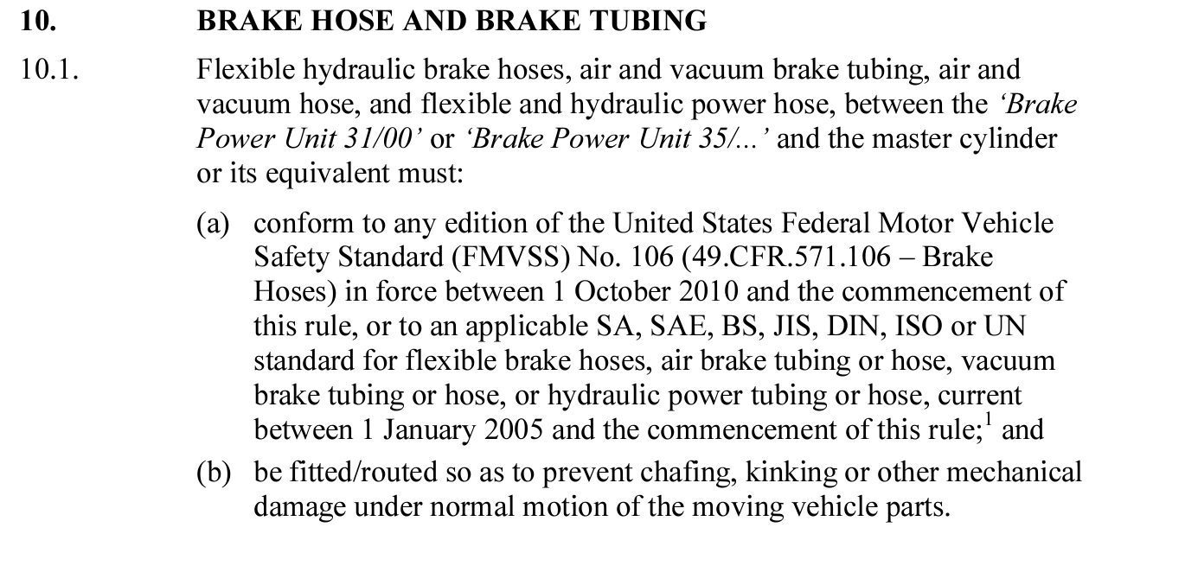
ADR 88 – Stability Control (SEV Exempt)
ADR 89 – Brake Assist (SEV Exempt)
ADR 98 – Advanced Emergency Braking for Passenger Vehicles and Light Goods Vehicles (SEV Exempt)

Functional Requirements
The brakes are, under normal circumstances, designed to slow down and stop the vehicle. This works through clamping down on the brake disc.

Abnormal Operation: Emergency Scenarios
In emergencies, brakes can be operated differently to suit the scenario. For example, the ABS will help prevent a lock up of the wheels in cases where the braking force exceeds static friction. Pedestrian sensors, crash avoidance?

Abnormal Operation: User Error
N/A

Testing/Maintenance/Fault Diagnostic
The brakes will have to be tested prior to heavy usage. This can be done through measuring the stopping distance or a decelerometer to measure G-forces. Brakes will have to be maintained regularly, through checking brake pad wear (sensor), brake disc wear, brake line condition, and the condition of the hydraulic braking fluid. Faults can be diagnosed through the OBD2 port (?) and through looking at brake traces and temperatures.

Performance Requirements

Teamwide Specifications
Regen braking?

Technical Specifications
Maximum longitudinal G-force during braking is approximately 1.3G.

Safety Specifications
Temperature

Interface Requirements
Interior – Pedal Box, Pedal Placement

Reliability Requirements
It is crucial that the brakes are reliable. Brake fade must be mitigated through various methods (friction fade, mechanical fade, fluid fade). Significantly, fluid fade occurs when the brake fluid starts boiling due to hard brake usage. Brake fluid must be changed regularly due to its hygroscopic properties (reduces boiling point). Pad fade can occur when the pads exceed thermal capacity and stopping distance is greatly increased.
Redundancy is integrated through two master cylinders in case of failure of either braking axle.

External Requirements
-

